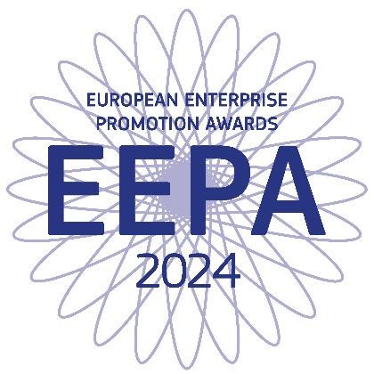

The European Enterprise Promotion Awards identify and recognise the most successful promoters of enterprise and entrepreneurship around Europe, showcase best entrepreneurship policies and practices, raise awareness of the added value of entrepreneurship and encourage and inspire potential entrepreneurs.

There are six categories:

- Promoting the entrepreneurial spirit
Recognises initiatives at national, regional or local level that promote an entrepreneurial mindset especially among young people and women.

- Investing in entrepreneurial skills
Recognises initiatives at national, regional or local level to improve entrepreneurial, managerial and employee skills.

- Supporting the digital transition
Recognises initiatives that support the digital transition of enterprises enabling them to develop, market and use digital technologies, products and services of any kind.

- Improving the Business Environment and Supporting the Internationalisation of business
Recognises innovative policies and initiatives at national, regional or local level, which render Europe the most attractive place to start a business, operate it, make it grow and scale it up in the Single Market, simplify legislative and administrative procedures for businesses and implement the “Think Small First” principle in favour of small and medium-sized enterprises.

- Supporting the sustainable transition
recognises policies and initiatives at national, regional or local level that support the sustainable transition and support environmental aspects such as the circular economy, climate neutrality, clean energy, resource efficiency or biodiversity through, for example, sustainable skills development and matchmaking as well as funding.

- Responsible and inclusive entrepreneurship
Recognises national, regional or local initiatives by authorities, public/private partnerships or SMEs that promote corporate social responsibility among small and medium sized enterprises. This category will also recognise efforts to promote entrepreneurship among disadvantaged groups such as the unemployed, especially long term unemployed, legal migrants, disabled or people from ethnic minorities.

The Jury’s Grand Prize can be from any category and will go to the entry considered the most creative and inspiring entrepreneurship initiative in Europe.

So, if you are a national, regional or local authority, public-private partnership, or SME* (Responsible and inclusive entrepreneurship category only) from anywhere in the EU, in the SME pillar of the Single Market Programme Support to SMEs - European Commission (europa.eu) and have worked on a successful initiative that has boosted your economy either at national, regional or local level, you are urged to participate!

There are two selection stages; only by completing initial selection at national level can entrants be considered for the European Awards. A high-profile Jury will select the final winners, to be announced at the award ceremony in November 2024.

For full information on the awards:

https://ec.europa.eu/growth/smes/supporting-entrepreneurship/european-enterprise-promotion-awards_en

Jelena Scekic
Republic of Serbia
Ministry of Economy
Department for SME Development
Kneza Milosa 20, 11 000 Beograd, Republika Srbija
T: +381 11 333 4213
E: jelena.scekic@privreda.gov.rs
W: www.privreda.gov.rs

Iva Matić
Republic of Serbia
Ministry of Economy
Department for SME Development
Kneza Milosa 20, 11 000 Beograd, Republika Srbija
T: +381 11 333 4215
E: iva.matic@privreda.gov.rs
W: www.privreda.gov.rs

Milica Stankovic
Republic of Serbia
Ministry of Economy
Department for SME Development
Kneza Milosa 20, 11 000 Beograd, Republika Srbija
T: +381 11 333 4144
E: milica.stankovic@privreda.gov.rs
W: www.privreda.gov.rs
An initiative of the European Commission,DG Internal Market, Industry, Entrepreneurship and SMEs

*SMEs as set out in SME definition (europa.eu)

